**PieChecker IOS**

**Introduction**:

This application has been made to be used by a PieChecker user. The IOS application is designed to run on iPhones, making it remotely easier to keep control over your bakings and as a another choice of viewing, alongside the website. The application will use a live streaming website as a source, this being TwitchTv. The application is created using Xcode 5.0 and Adobe Photoshop CS5 for visuals.

**Initial Design:**

The application is designed to have four different pages to navigate through, including the Login Page. The pages can be navigated through the use of a navigation item, being a bar button item. These buttons are placed on the top corners of the interface and when tapped or clicked, the user is redirected to that page.

**Launch Image:**

This is the first thing seen when launching the application. This is just a plain .png picture which is put there for visual design purposes only, this is nicer to look at instead of a plain white image.

**Login Page:**

When the application is opened, this page is the first thing that is seen and from here they can login with their username and password. As of now, the username and password are not of a PieChecker account since that service is not exactly available.

**Navigation Menu:**

From this section they can navigate through the applications different pages, the three pages available are *Profile, Video,* and *Gallery Page*. This page, also acts as the “homepage” for the application. This is where the users will come back to after they are done with another page, they will press the “back” button and be redirected to this page. At the bottom of the page, a logout function is also available for the user; when this button is clicked they are redirected to the login page where they would have to login again in order to grant access. All this is controlled by the use of a navigation controller, allowing the upper part of the interface to act as a toolbar.

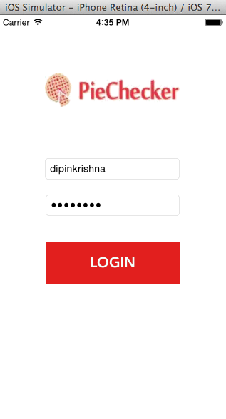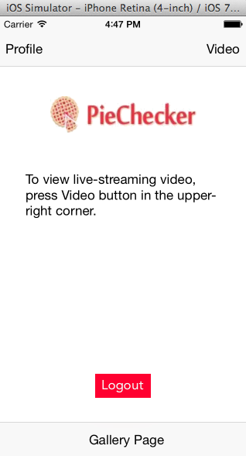

**Profile Page:**

This is the users profile page where information about themselves may be written and a profile picture would be set. This is all locally put it since the application is not connected to a database. The page is mostly made up of *Labels, views* and *image views*.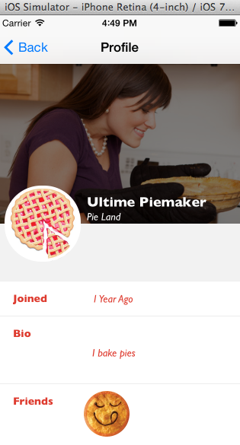

**Video Page:**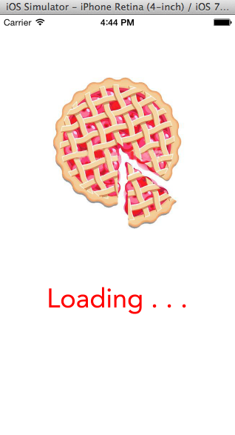

The video page was difficult to figure out at first since we just wanted a specific live-stream from the Twitch Tv website. This requires more time and expertise, instead a UIWebView was used. This allows the application to fetch a website by doing some coding in the .h and .m files. Below on the left image, an Activity Indicator displays a loading image until the website has fully loaded. On the right, the live-streaming video has been tapped on via the loaded website and is providing a live-stream via the UIWebView.

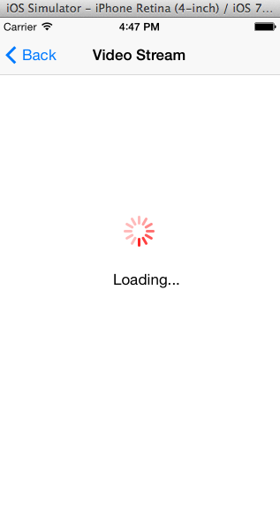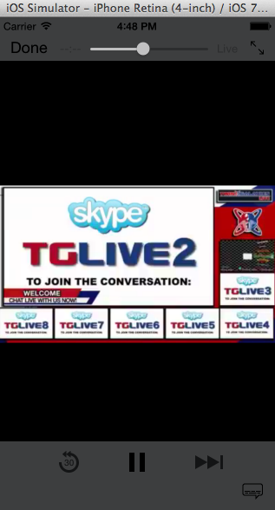

**Conclusion:**

There have been quite a few of obstacles to face. Since this is the first time programming an iOS application, this became a bit of a challenge. The biggest issue was by far trying to fix the livestream, some services don’t allow live streaming outside of their own application. Even though a live streaming service may allow it, it is difficult for a beginner to find a way. The design has looked different at different times, but changes have occurred due to simpler routes. A sidebar function was being planned to be added but it proved difficult, when the combination of all pages had to occur. So, the navigation controller combined with the bar button items seemed to be a easier solution.

This application can be improved in many ways but it takes time. Since everything is run locally inside of Xcode, a lot of server coding would have to be made in order to store profile information, passwords and usernames, etc. In conclusion, the application can be run as a demo of what it may look like and part functionalities such as the live-streaming which is essential for this application and its users.